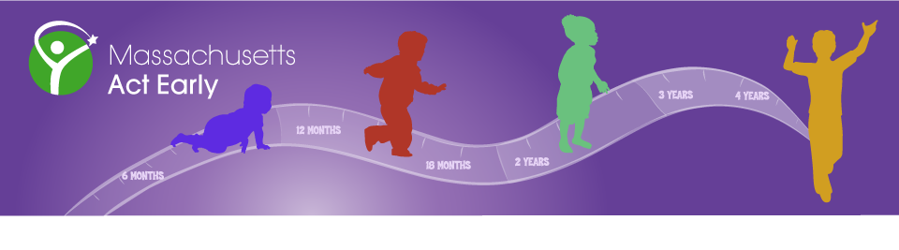
Summit Program
Massachusetts Act Early Spring 2016 State Team Summit Meeting
Building Capacity as an Early Identification Learning Community
April 29, 2016

Morning Informational Presentations Faculty Conference Room

Registration and Networking Breakfast 8:30 – 9:00

Opening Remarks and Update on CDC “Learn the Signs. Act Early.” Resources 9:00 – 9:30
Elaine Gabovitch, MPA, UMass Medical School – E.K. Shriver Center

The Opening Session of the Summit meeting will share important information about the Massachusetts Act Early state campaign as well as updates from the CDC’s "Learn the Signs. Act Early." public awareness program for parents, educators and health care providers. LTSAE materials, trainings, and resources share important information about healthy developmental milestones in young children as well as what to do when there are developmental concerns.

The Rapid Interactive Screening Test for Autism in Toddlers (RITA-T): 9:30 – 10:00
A New Interactive Screening Test for Autism in Toddlers
Roula Choueiri, MD, UMass Medical School, Department of Developmental-Behavioral Pediatrics

During this presentation, Dr. Choueiri will present the research, and the development of the RITA-T. Preliminary results, completed studies and current ongoing clinical projects will be presented. Components of the RITA-T and videos of its administration, developmental constructs, and scoring will be discussed. Opportunities for clinical models will be presented. A workshop will follow in the afternoon for those who wish to train for the RITA-T.

Early Identification of Autism: Perspectives from Cognitive Neuroscience 10:00 – 10:45
Morgan Crossman, PhD, Laura Edwards, PhD and Cora Mukerji (PhD Candidate)
Boston Children's Hospital, Laboratories of Cognitive Neuroscience

This presentation introduces a cognitive neuroscience approach to study early markers of autism in high-risk populations. We discuss the goals and challenges of early identification; the electrophysiological, eye-tracking, and clinical methods used in the Laboratories of Cognitive Neuroscience; and findings from a longitudinal study of infant siblings of children with autism. We will also present our newest research study, the Infant Screening Project, which will compare neural and behavioral risk markers in a population-level screen-risk sample of infants to infants at familial risk for ASD and to low risk controls.

The Benefits of Using a Telehealth Service Delivery Model to Improve 11:00 – 11:30
Communication Skills in Children with Autism Spectrum Disorder
Mary Andrianopoulos, PhD, University of Massachusetts Amherst, Department of Communication Disorders

The use of technologies and computer-assisted instruction are reported to be more effective and reinforcing to children with autism. This presentation will address the efficacy of using a Telehealth (Telepractice) service delivery model compared to on-site face-to-face intervention services to improve outcomes and communication skills in students on the autism spectrum. Empirical evidence to date supports that speech language pathology services delivered to students with autism in elementary, middle, and high school grades using Telepractice are as good, and in some cases more beneficial, than on-site face-to-face services.

Diversity in Early Identification Panel 11:30 – 12:15
Elaine Gabovitch, Facilitator

Autism and African Americans: Combating Diagnostic Disparities
Jacqueline Williams-Hines, Founder and Executive Director, No Small Victories
This presentation will examine potential cultural contributors of diagnostic disparities for the African American community. It will approach hidden conversations and explore ways to get stakeholders to the table speaking the same language.

Cultural Competence in an Autism Evaluation: A Case Study About a Cantonese-English Teenager
Shirley Huang, MS, CCC-SLP, Architects for Learning
The purpose of this talk is to highlight how cultural considerations impact assessment and diagnostic decision making. This talk will present a case study about a 13-year-old, bilingual Cantonese-English speaking teenage girl. She was administered a culturally and linguistically sensitive social communication evaluation that included the Autism Diagnostic Observation Schedule-2nd Edition (ADOS-2).

Language Rights of Limited English Proficient Individuals Overview
Tere Ramos, Esq., Massachusetts Law Reform Institute
Many children with disabilities come from families where English is not the first language, and as a result have problems in getting the services their families need. Language access is a civil right that providers and even advocates often overlook. This presentation will explain the legal rights for Limited English Proficient and Deaf and hard of hearing families, and we will discuss how to assert those rights. Ramos will give a brief overview with a full workshop in the afternoon.

Networking Lunch 12:15 – 1:00

Afternoon Practical Application Workshops Goff Suite, 2nd Floor
RITA-T Workshop 1:00 – 4:00
Roula Choueiri, MD, UMass Medical School Room 1, Goff # TBD

This workshop will demonstrate and train attendees in the administration and scoring of the RITA-T. Review of learning videos, practice videos and reliability of training will be discussed. At the end of the workshop the attendee will know the administration and scoring of the RITA-T. We will discuss opportunities for clinical models using the RITA-T to facilitate early identification of toddlers.

Considering Culture in Autism Screening Workshop 1:00 – 4:00
Elaine Gabovitch, MPA & Kathleen Braden, MD, UMass Medical School-Shriver Center Room 2, Goff # TBD

Considering Culture in Autism Screening: A Cultural & Linguistic Competency Training Curriculum for Pediatric Providers uses an interactive approach to educate pediatric providers and other early childhood professionals about culturally competent screening, evaluation, and referral to intervention services for children with ASD. The training will include case studies, videos and supplementary materials, and will focus on the needs of families whose primary languages are not English. Videotaped interviews from parents of children with ASD from four cultures reflect on their experiences through the identification process sharing their unique cultural perspectives and insights.

Cultural Brokering Model in Improving Services for Children with Autism 1:00 – 2:30
Oanh Thi Thu Bui, MHA, MPA, Federation for Children with Special Needs Room 3, Goff # TBD

The U.S. medical system is like a maze for non-English speaking parents to navigate. Parents from diverse communities may have different understanding about developmental milestones and different kinds of disability. A common problem for diverse parents may be difficulty accepting a diagnosis of autism for their young children and refusing to allow services to come into the homes. Many parents do not know what to do after receiving the diagnosis of autism. Due to language barriers, these parents might not able to communicate meaningfully with their child’s care team. Effective use of cultural brokering model can bridge the gap in cross-cultural communication, improving the interconnection between families and professionals and service delivery for non-English families of children with autism.

Autism Family Navigation & Project EARLY 1:00 – 2:30
Ivys Fernandez-Pastrana, Esq., & Jenna Sandler, MPH, Boston University/Boston Medical Center Room 4, Goff # TBD

Family Navigation is an innovation of patient navigation developed by a research team at Boston Medical Center over recent years to support underserved families of children diagnosed with ASD. Project EARLY is a National Institute of Mental Health-funded multi-site study to improve early diagnosis and linkage to services among very young children at risk for autism. The study is comparing the effectiveness of family navigation vs. conventional care management and has the following five goals: 1. To achieve an 80% screening rate for indicators of autism across all sites; 2. To implement a decision rule for referral to autism evaluation; 3. To shorten the time to diagnosis among children suspected to have autism; 4. To shorten the time to deployment of autism services among those diagnosed, and 5. To improve engagement with autism services. Best practices for developing and implementing a Family Navigation program will be described.

Language Rights of Limited English Proficient Individuals 1:00 – 2:30
Tere Ramos, Esq., Massachusetts Law Reform Institute Room 5, Goff # TBD

Many children with disabilities come from families where English is not the first language, and as a result have problems in getting the services their families need. Language access is a civil right that providers and even advocates often overlook. This presentation will explain the legal rights for Limited English Proficient and Deaf and hard of hearing families, and we will discuss how to assert those rights. Ramos will offer a few afternoon workshop on this topic with a brief overview in the morning.

